Level 9 – Number and algebra

Overview
Task name This expression is the same as that expression when …
Learning intention To identify equivalent forms of simple algebraic equations
Duration 30 minutes

Links to the Victorian Curriculum
These work samples are linked to Level 9 of the Mathematics curriculum.

Extract from achievement standard
Students use the distributive law to expand algebraic expressions, including binomial expressions, and simplify a range of algebraic expressions.

Relevant content description
- Apply the distributive law to the expansion of algebraic expressions, including binomials, and collect like terms where appropriate (VCMNA306)

Links to NAPLAN

Minimum standards – numeracy
Year 9: Algebra, function and pattern – Equivalence
Students can establish equivalence between algebraic expressions. For example, students can generally:
- identify equivalent forms of simple algebraic expressions.

Student work samples −
Expressions (Questions a and b)
These work samples were created by students working at
Level 9. Evidence of student achievement has been annotated.
Victorian Curriculum link
Apply the distributive law to the expansion of algebraic expressions, including binomials, and collect like terms where appropriate (VCMNA306)

This expression is the same as that expression when …
Introduction
This task involves the equivalence between expanded and factorised forms of simple algebraic expressions.
Students should be familiar with the use of the distributive rule for expansion of simple expressions with positive integer coefficients such as: 2(𝑥 + 3) = 2𝑥 + 6 and (𝑥 + 3) = $x^{2}$+ 3𝑥.

Sample 1
a. Find a positive integer value of c for which $x^{2}$ + 8𝑥 + 𝑐 can be written as the product (multiplication) of two different linear expressions with positive integer coefficients.
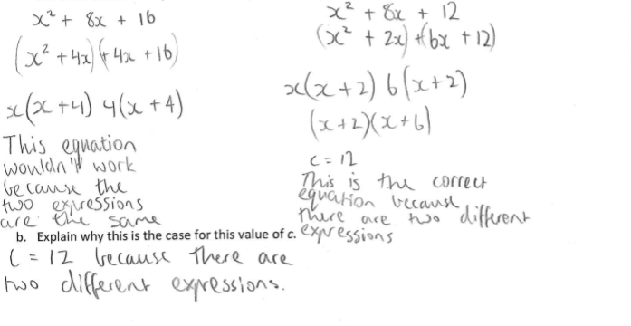

Factorises two expressions with 8x terms and different constant terms

Identifies c = 12 and compares to distinct linear factors

Identifies c = 16 and compares to distinct linear factors

Selects solution with two distinct linear factors

Sample 2
a. Find a positive integer value of c for which $x^{2}$ + 8𝑥 + 𝑐 can be written as the product (multiplication) of two different linear expressions with positive integer coefficients.
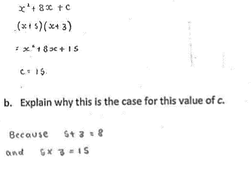

Sample 3
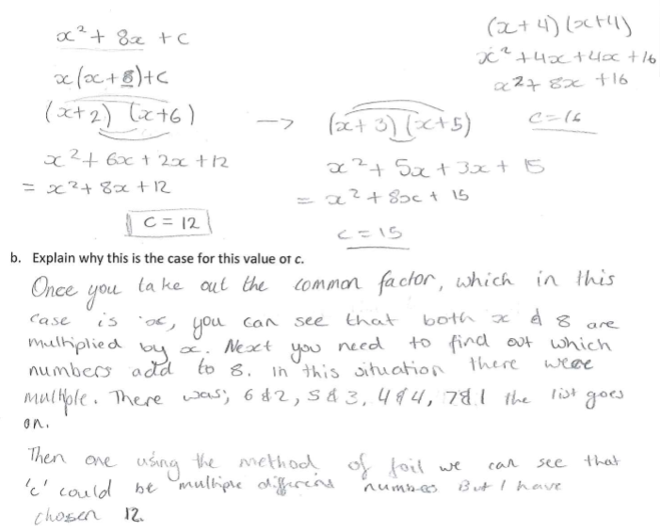
a. Find a positive integer value of c for which $x^{2}$ + 8𝑥 + 𝑐 can be written as the product (multiplication) of two different linear expressions with positive integer coefficients.

Expands pair of distinct factors with resulting 8x term and constant term of 15

Identifies c = 15

Explains in terms of pair of values satisfying coefficient relations

Expands two pairs of distinct linear factors to obtain two solutions for c

Identifies there are several possible solutions

Selects particular solution c=12

Sample 4
a. Find a positive integer value of c for which $x^{2}$ + 8𝑥 + 𝑐 can be written as the product (multiplication) of two different linear expressions with positive integer coefficients.

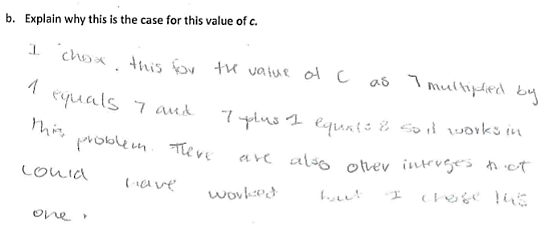

Sample 5
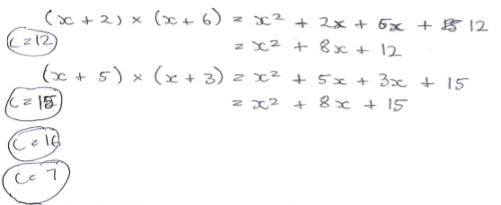
a. Find a positive integer value of c for which $x^{2}$ + 8𝑥 + 𝑐 can be written as the product (multiplication) of two different linear expressions with positive integer coefficients.

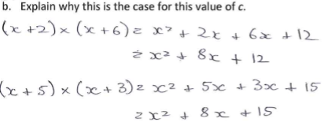

States solution and verifies using coefficient relations

States factorised form

Identifies possibility of other solutions without listing any

Expands to identify solutions with 8x term

Lists four possible values for c including perfect square case

Re-states working for two selected solutions

Student work samples −
Expressions (Questions c and d)
These work samples were created by students working at
Level 9. Evidence of student achievement has been annotated.
Victorian Curriculum link
Apply the distributive law to the expansion of algebraic expressions, including binomials, and collect like terms where appropriate (VCMNA306)

Sample 1
c. Find a positive integer value of c for which 𝑥² + 8𝑥 + 𝑐 cannot be written as the product (multiplication) of two linear expressions with positive integer coefficients.

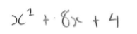

d. Explain why this is the case for this value of c.

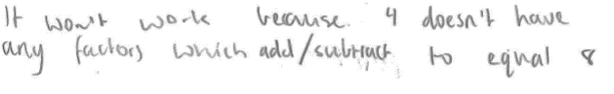

Writes quadratics expression x² + 8x + c with c = 4

Applies heuristic to explain why there is no product of linear expressions when c = 4

Sample 2
c. Find a positive integer value of c for which x² + 8x + c cannot be written as the product (multiplication) of two linear expressions with positive integer coefficients
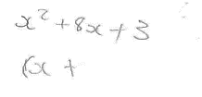

d. Explain why this is the case for this value of c.
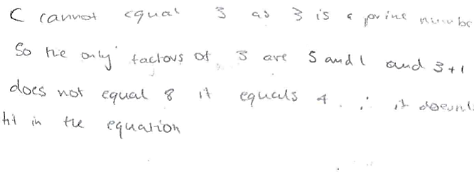

Sample 3
c. Find a positive integer value of c for which x² + 8x + c cannot be written as the product (multiplication) of two linear expressions with positive integer coefficients
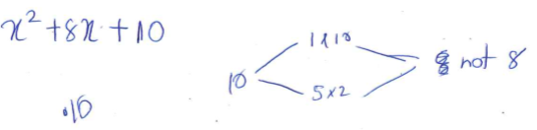

d. Explain why this is the case for this value of c.

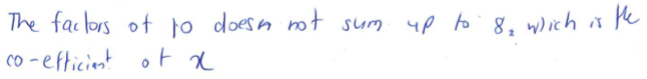

Writes quadratic expression x ² + 8x + c with c = 3

Applies heuristic to explain why there is no product of linear expressions when c = 4

Writes quadratic expression x² + 8x + c with c = 10

Notes factors of 10 do not sum to 8, the coefficient of x

Student work samples −
Expressions (Questions e and f)
These work samples were created by students working at
Level 9. Evidence of student achievement has been annotated.

Victorian Curriculum link
Apply the distributive law to the expansion of algebraic expressions, including binomials, and collect like terms where appropriate (VCMNA306)

Sample 1
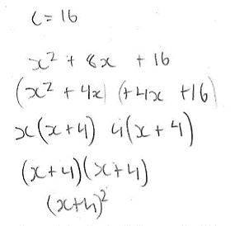
e. Find the positive integer value of c for which 𝑥² + 8𝑥 + 𝑐 can be written as the product (multiplication) of two identical linear expressions with positive integer coefficients.

f. Explain why this is the case for this value of c.

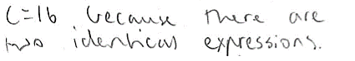

Identifies c = 16 as a solution

Factorises to obtain two identical linear factors of x + 4

Writes as a perfect square

States the linear expressions are identical when c = 16

Sample 2
e. Find the positive integer value of c for which 𝑥² + 8𝑥 + 𝑐 can be written as the product (multiplication) of two identical linear expressions with positive integer coefficients.
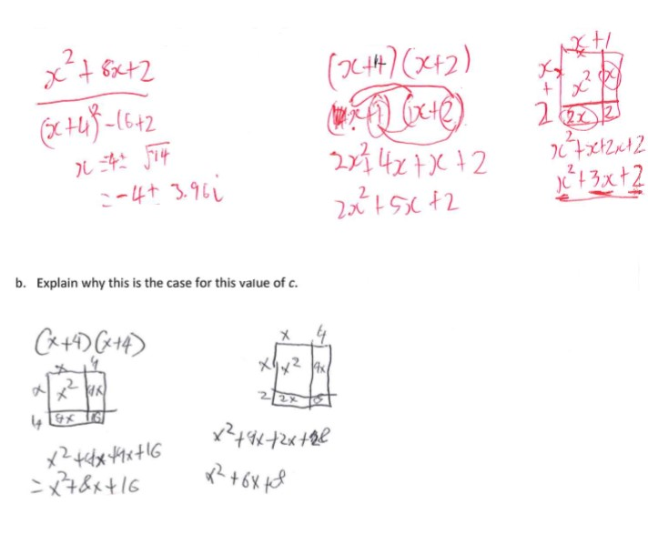
f. Explain why this is the case for this value of c.

Attempts two combinations of linear expressions that do not work

Uses diagram for perfect square form (x + 4) (x + 4) and shows expansion

Sample 3
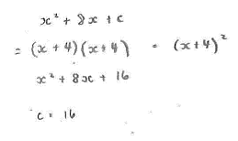
e. Find the positive integer value of c for which 𝑥² + 8𝑥 + 𝑐 can be written as the product (multiplication) of two identical linear expressions with positive integer coefficients

f. Explain why this is the case for this value of c.
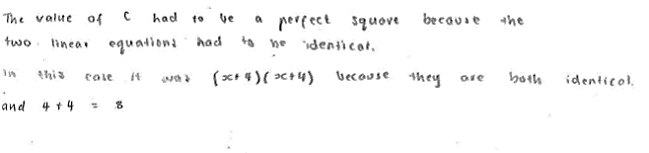

Factorises and states in perfect square form

States the value of c

Explains that perfect square form requires identical linear expressions

Sample 4
e. Find the positive integer value of c for which 𝑥²+ 8𝑥 + 𝑐 can be written as the product (multiplication) of two identical linear expressions with positive integer coefficients
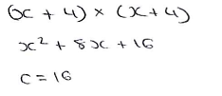

e. Explain why this is the case for this value of c.
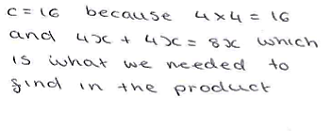

Expands pair of identical linear expressions

States the value of c

Explains the relationship between coefficients and constant term

Where to next for the teacher?
When the task on which these annotated student work samples is based has been used as a classroom activity, there is opportunity to gather data on student achievement to help inform further teaching.
An analysis of student responses, on an individual, group or whole class basis, can be used to develop and direct student learning with respect to the following content.

For students needing to review underpinning knowledge and skills at Level 8
- Extend and apply the distributive law to the expansion of algebraic expressions (VCMNA279)

For students consolidating knowledge and skills at Level 9
- Apply set structures to solve real-world problems (VCMNA307)

For students moving on to new knowledge and skills at Level 10
- Simplify algebraic products and quotients using index laws (VCMNA330)
- Substitute values into formulas to determine an unknown and re-arrange formulas to solve for a particular term (VCMNA333)

Resources
- Mathematics Sample Programs, Victorian Curriculum and Assessment Authority (VCAA) – This set of sample programs covering the Victorian Curriculum Mathematics: F–10 were developed as examples to illustrate how the Mathematics curriculum could be organised into yearly teaching and learning programs.
- Numeracy Learning Progressions, Victorian Curriculum and Assessment Authority (VCAA) – The Numeracy Learning Progressions amplify, extend and build on the numeracy skills in the Victorian Curriculum Mathematics F–10 and support the application of numeracy learning within other learning areas.
- FUSE, Victorian Department of Education and Training (DET) – The FUSE website provides access to digital resources that support the implementation of the Victorian Curriculum F–10, including an extensive range of activities and other resources for Primary Mathematics and Secondary Mathematics.
- Mathematics Teaching Toolkit, Victorian Department of Education and Training (DET)
- Mathematics Curriculum Companion, Victorian Department of Education and Training (DET)
- Victorian Numeracy Portal, Victorian Department of Education and Training (DET)
- Aligned Australian Curriculum Resources (Mathematics), Australian Curriculum, Assessment and Reporting Authority (ACARA)

